Query 1 :

SELECT sum(S.Units_Sold),S.item_type,S.country FROM

(select * from sales where sales.sales_channel='Online') S GROUP BY S.item_type,S.country;

Execution time = 0.015 sec

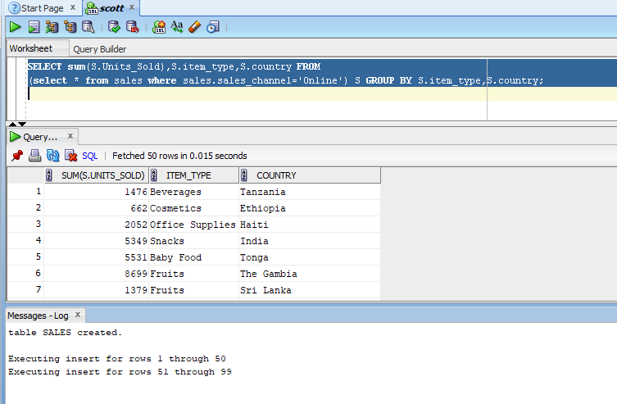

Query 2:

SELECT avg(S.Units_Sold),S.country FROM

(select * from sales where sales.sales_channel='Online') S GROUP BY S.country ORDER BY s.country;

Execution time = Negleible

